**Activation of linux on windows**

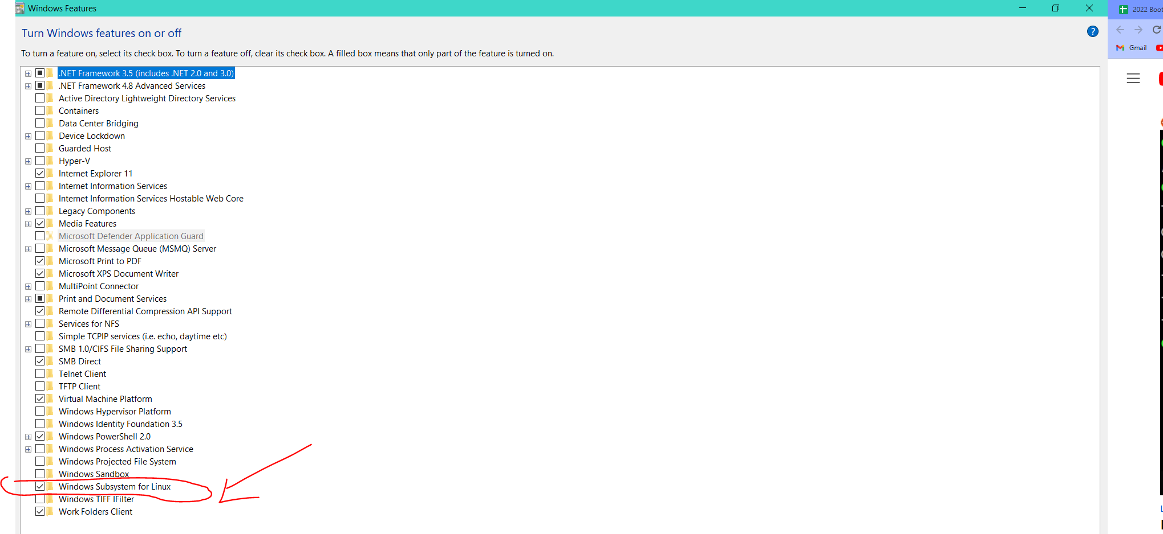

**Download and Intallations**

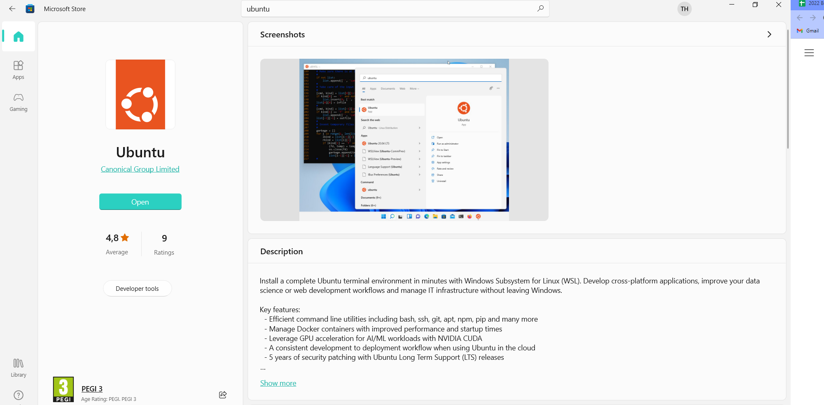

**Profile creation**

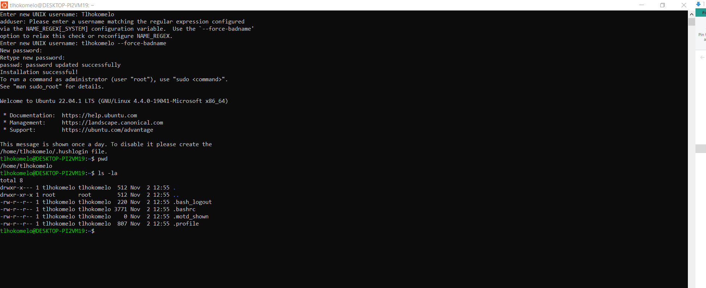

**Useful Commands:**

|  |  |
| --- | --- |
| **Command** | **Explanation** |
| cd <folder Name>/ | Takes you into the specific folder |
| ls -la | Lists all files in the folder |
| touch <file name> | Creates a file |
| nano <file name> | Edits a file (opens up the nano editor) |
| Ctrl X to exit |
| Y to save |
| Enter to keep the file name |
| cat <file name> | To see contents of file |
| sudo apt-get update | Updates packages within Linux to the latest version |
| sudo apt-get upgrade | Updates packages within Linux |
| sudo apt-get install tree | Installs the tree command (allows you to view your directory structure) |
| tree | Displays directory structure |
| cd | Switches back to the Linux home directory |
| nano ~/.bashrc | Edits the bashrc file within the Linux home directory to prepare for creating an alias |
| alias winhome='cd mnt/c/Users/thlok/' | Creates an alias into specified directory |
| source ~/.bashrc | Source the file for changes to take effect |
| winhome | Takes you to newly created alias home directory |
|  |  |
|  |  |
|  |  |
|  |  |
|  |  |
|  |  |
|  |  |
|  |  |
|  |  |
|  |  |
|  |  |

**Examples:**

* **Listing files in a folder**

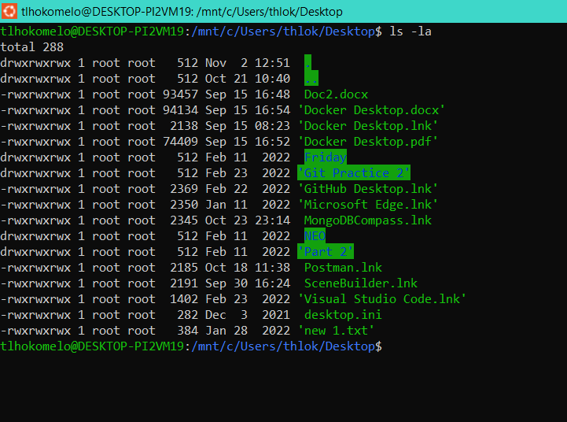

* **Creating a file**

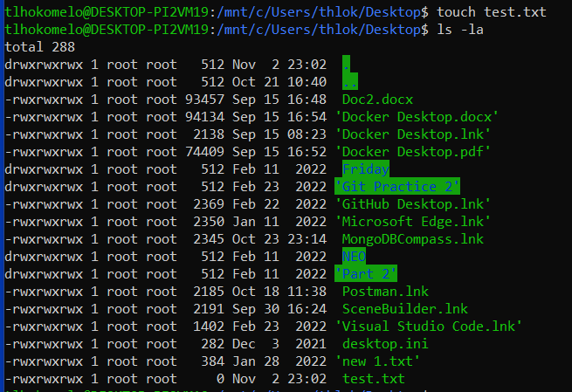

* **Editing a file**

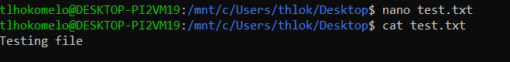

* **Updating packages within Linux**

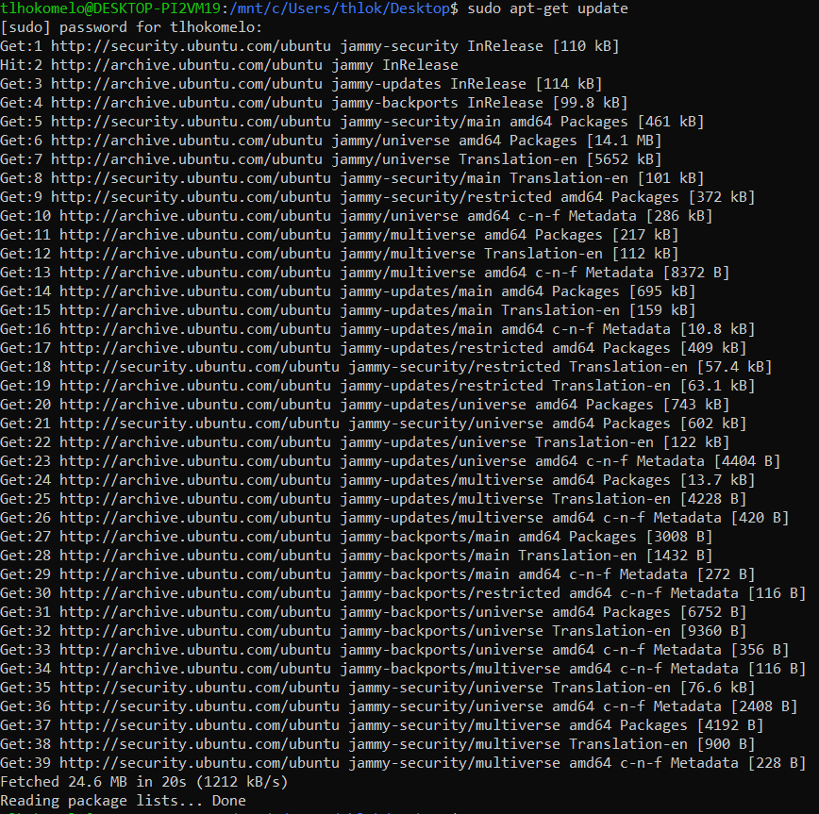

* **Upgrading packages within Linux**

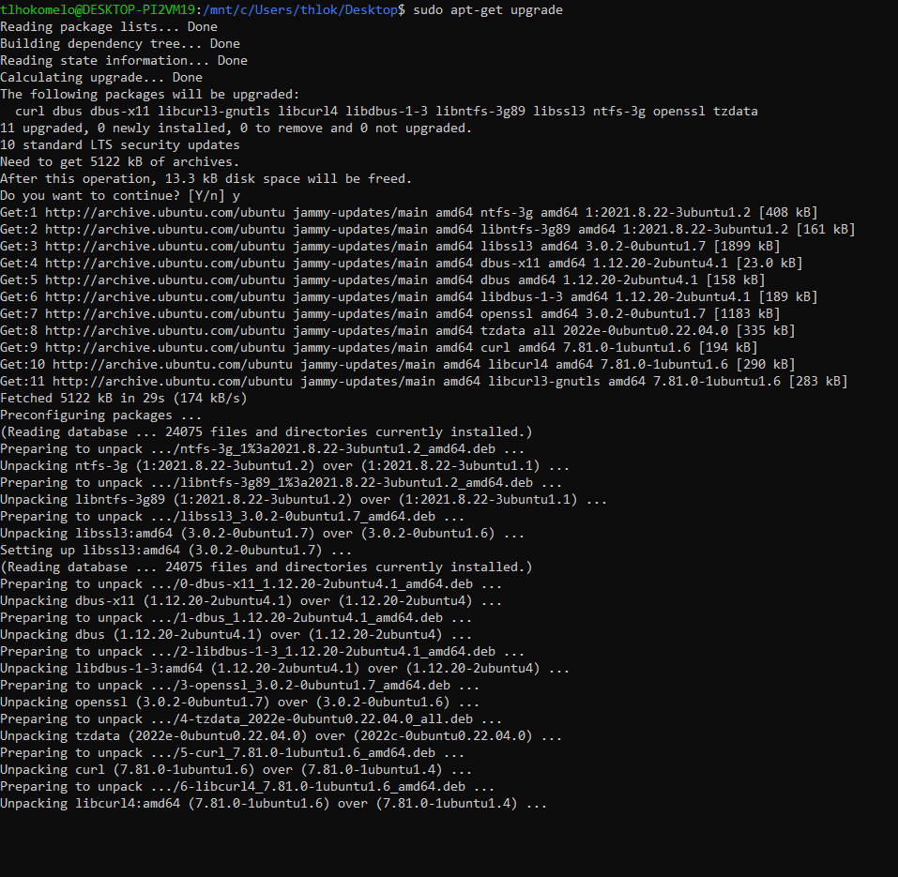

* Installing tree

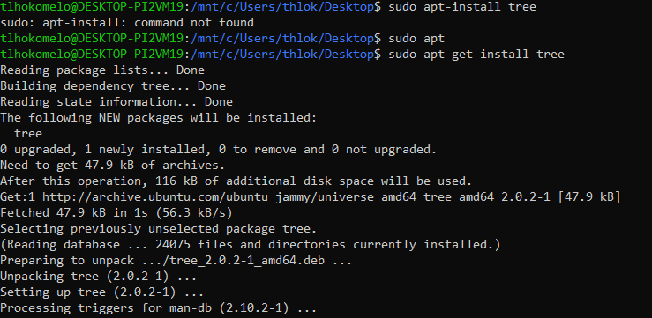

* Using the tree command to view directory structure

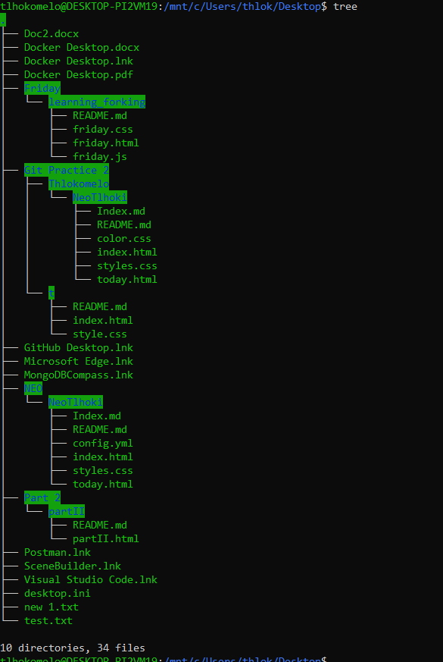

* Navigating to Linux home directory , editing it, creating an alias and navigating back to the newly created alias

